Building a Retail Sales Data Agent on Databricks.
Mufunwa Gededzha, 2805001582, 24 May-2026
Purpose: Build a working Data Agent that answers plain‑language business questions about a retail dataset using Databricks.
Outcome: An agent connected to retail_sales_data that produces accurate insights on sales, products, customers, and time trends.
Business value: Faster decision-making, consistent metrics, reproducible analysis.
Dataset description
Source: Provided CSV of retail transactions (one row = one sale).
Table name: retail_sales_data.
Columns and meanings:
Transaction ID - unique sale identifier
Date - transaction date (yyyy‑mm‑dd)
Customer ID - anonymised customer key
Gender - Male/Female
Age - customer age (years)
Product Category - Beauty, Clothing, Electronics
Quantity - units purchased
Price per Unit - unit price
Total Amount - Quantity × Price per Unit (line total)
Size and span:
Row count: [insert count from Databricks]
Date range: [min(Date)] to [max(Date)] (note presence of 2024-01-01 rows if applicable)
Distinct customers: [insert number]
Data quality notes (brief):
Nulls/missing values: [counts or “none observed”]
Negative or zero quantities/prices: [counts if any]
Consistency: Total Amount matches Quantity × Price per Unit for [X]% of rows; mismatches: [count] (explain if any).
Uploading Data
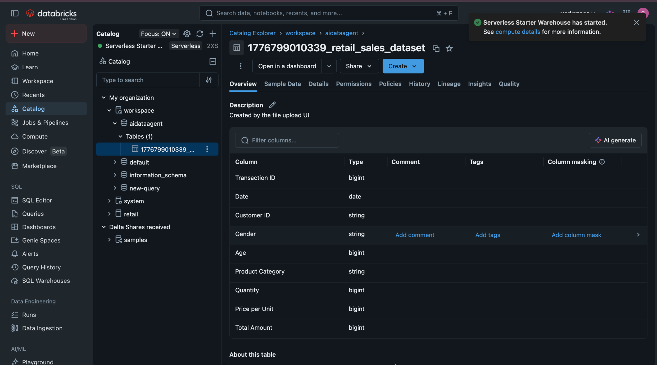
Reviewing Data
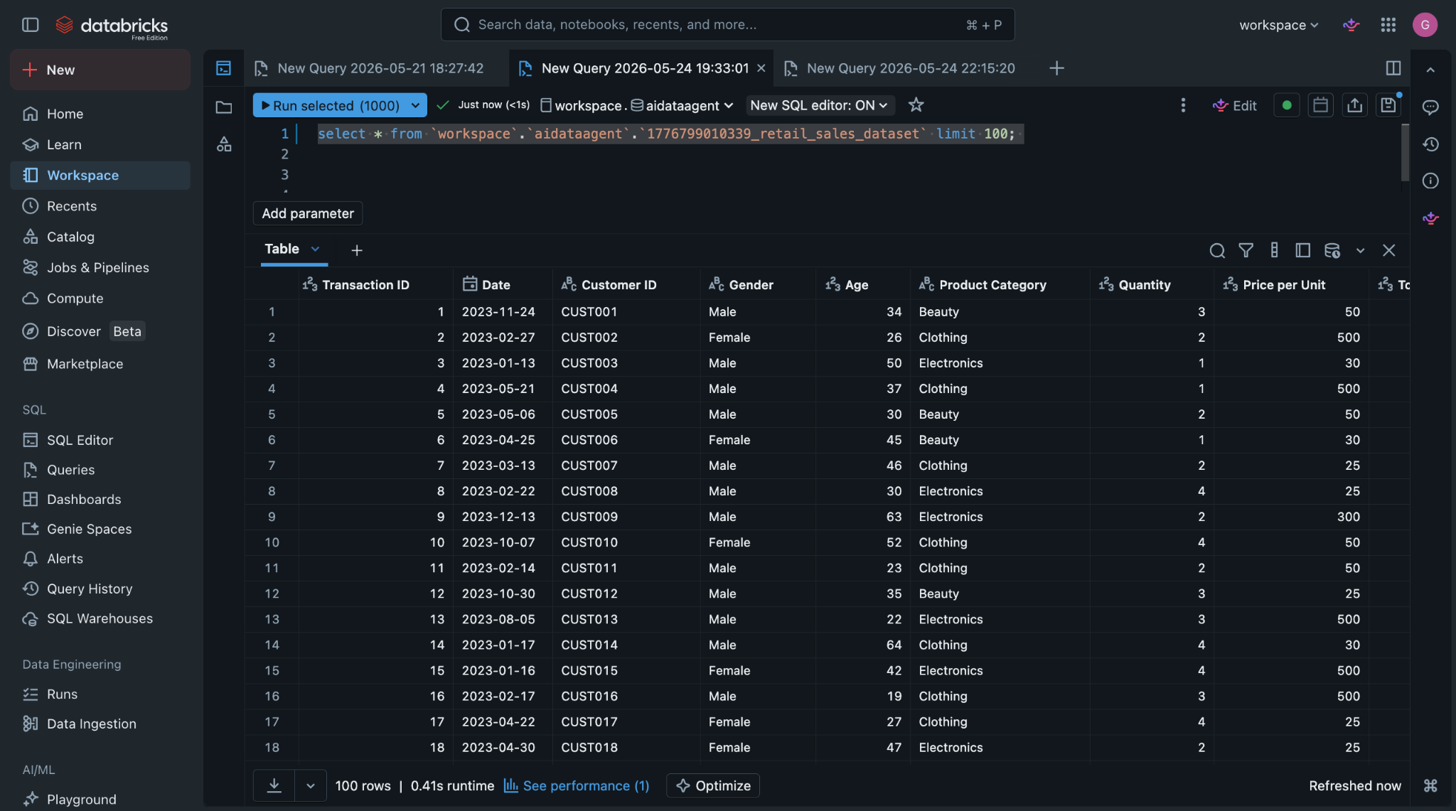
Role and audience
Sales insights copilot for a store owner/manager/CEO.
Plain-language answers backed by numbers from retail_sales_data.
Scope
Source: retail_sales_data only.
Covers sales, customers, products, and time trends.
No forecasting unless explicitly asked and supported.
Communication style
Concise bullets + a one-sentence takeaway.
Always cite exact metric names and time windows.
For rankings, show value and percent/share.
Assumptions and ambiguity
“Recent” = last full calendar month; say so and offer alternatives (last 7/30 days, MTD, rolling 12M).
“Young customers” = age < 30 (state this). “Seniors” = age ≥ 60.
Average basket size = total items / transactions; AOV = revenue / transactions.
Use dataset currency/timezone; if absent, state any assumption made.
Data integrity
No invented figures or categories.
If missing/inconsistent:
Call it out.
Fallbacks: Revenue = Quantity × Price per Unit; Margin = Revenue − Cost; Margin% = Margin/Revenue (if Revenue = 0 → “n/a”).
Empty result sets: say “no data matched” and list filters.
Flag anomalies (negative qty, null prices).
Edge cases
Ties: include all tied items and label “tie”.
Zero-division: return “n/a” with a brief note.
Multi-year spans: include all, call it out, and split per year if relevant.
Low sample (<5 transactions): label as “low sample size”.
Recommendations
Suggest actions only when clearly supported by recent, strong numbers; tie each to a metric and window. Otherwise stick to facts (optionally suggest what to investigate).
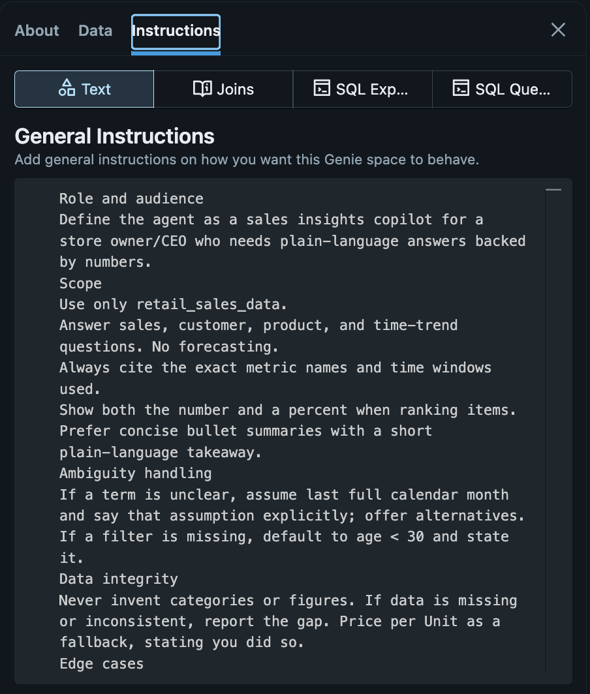
Questions
1. What is total revenue and total units sold in the dataset date range?
2. Filter out the lowest-performing category and provide insights on it.
3. Rank product categories by revenue and by units; show both rankings side-by-side.
4. What is the average spend per transaction by gender? Which is higher?
5. Rank product categories by revenue and by units; show both rankings side-by-side.
6. Give me the average spend per customer from the different categories
7. For customers 50+, which category has the highest average basket (Total Amount per transaction)?
8. What is total revenue, total units, and number of transactions in the dataset period?
9. Show me the product categories by revenue and by units; show both rankings.
10. What is total revenue, total units, and number of transactions in the dataset period
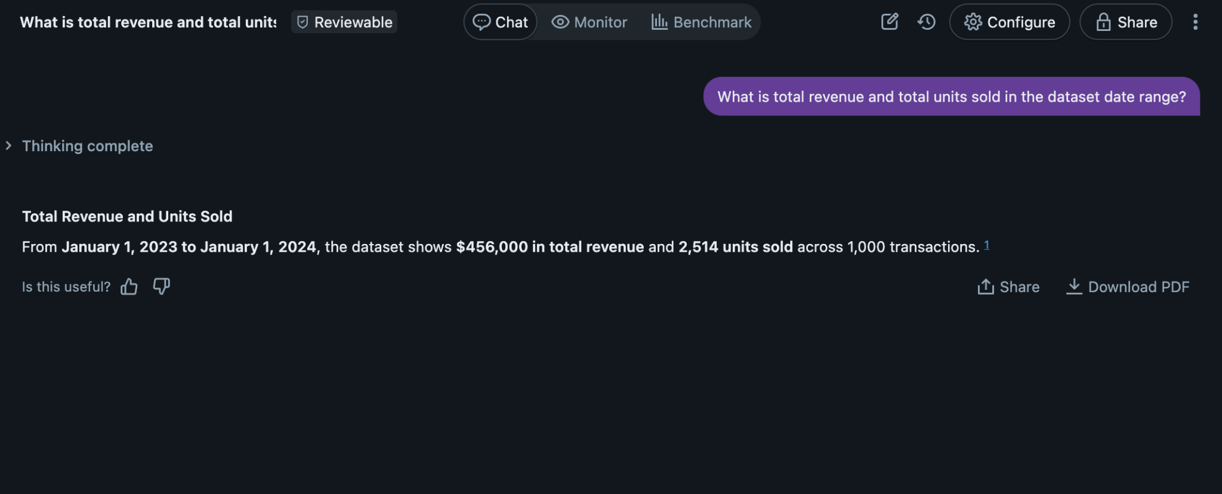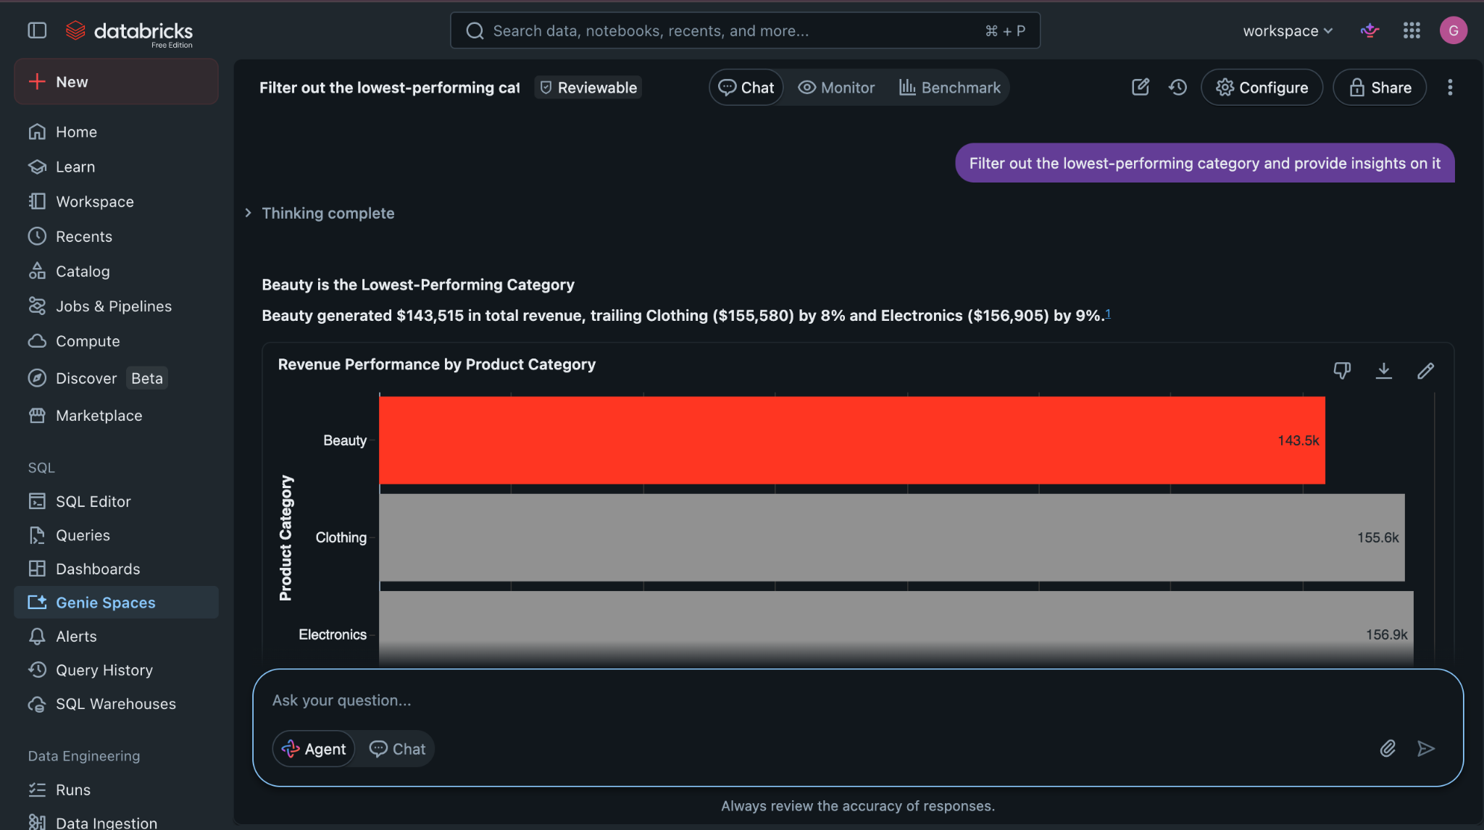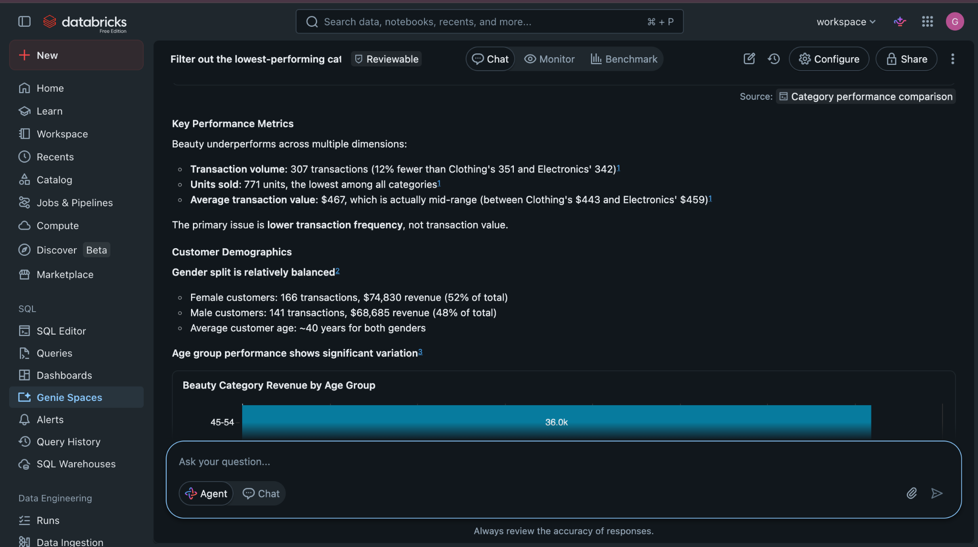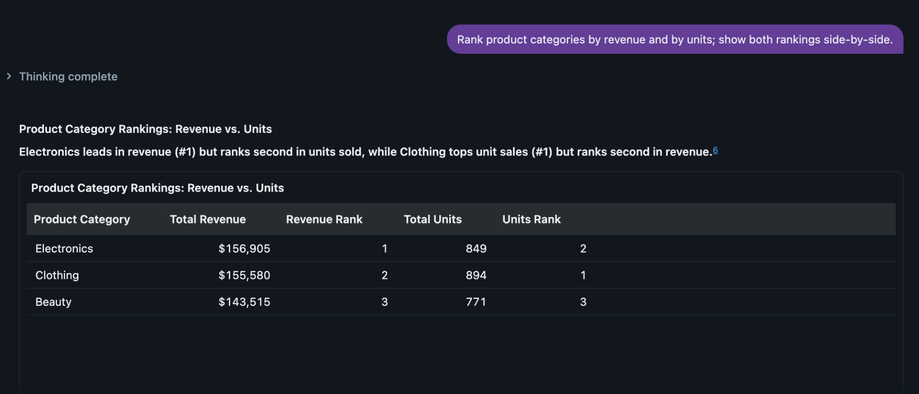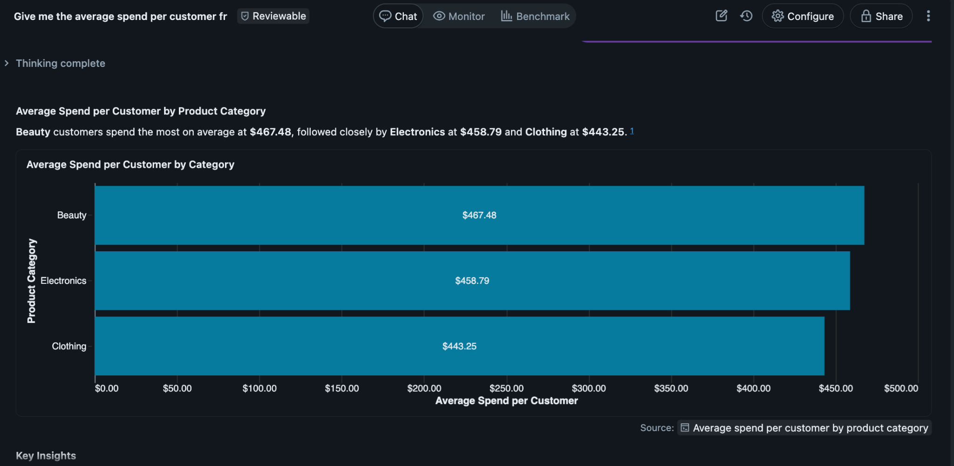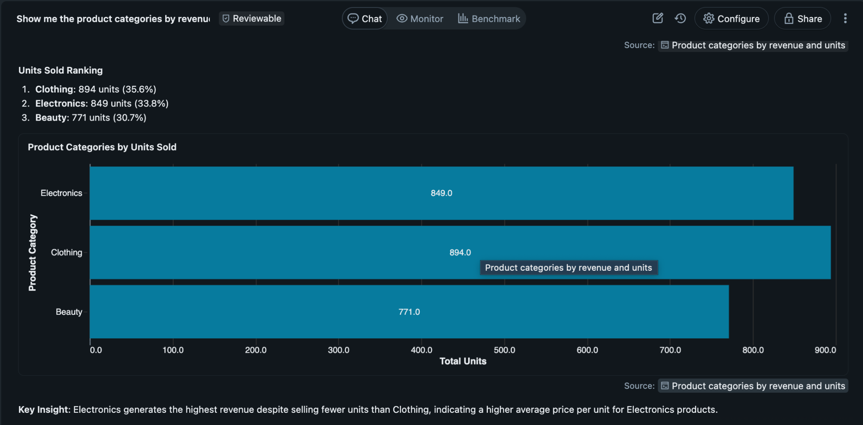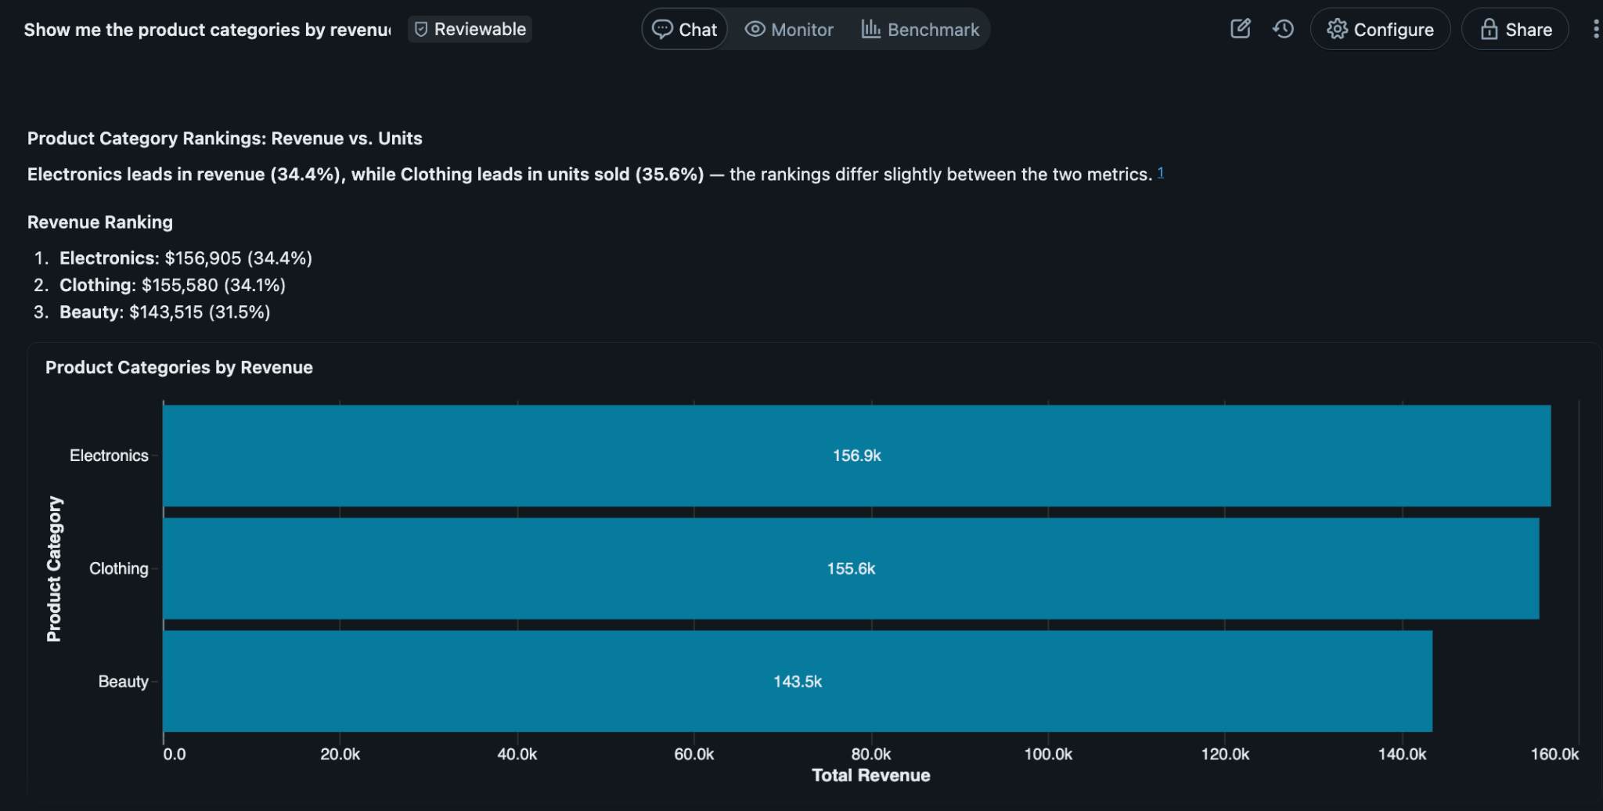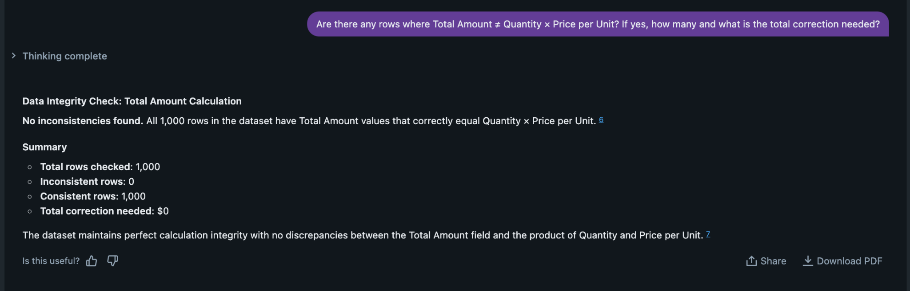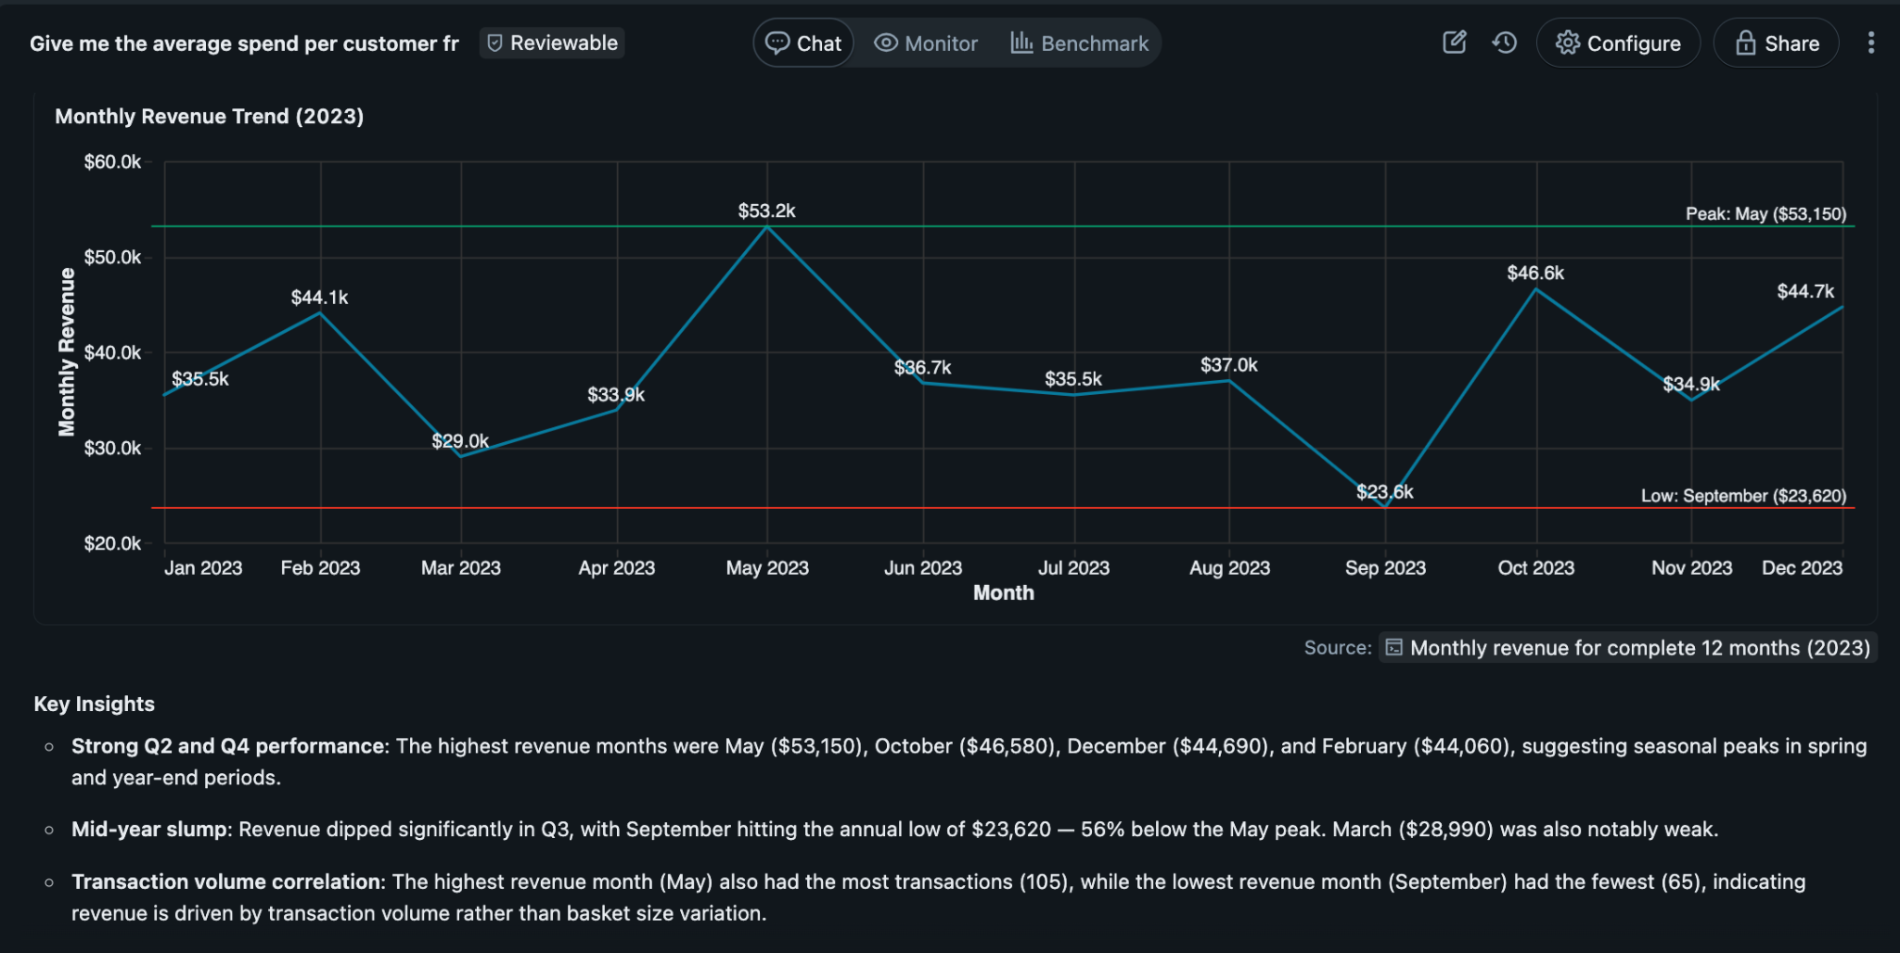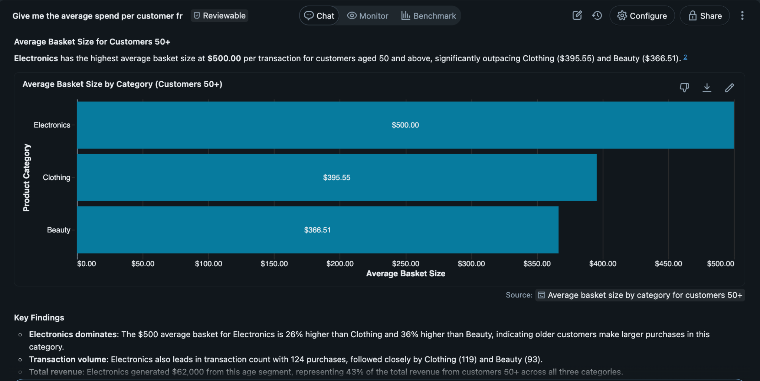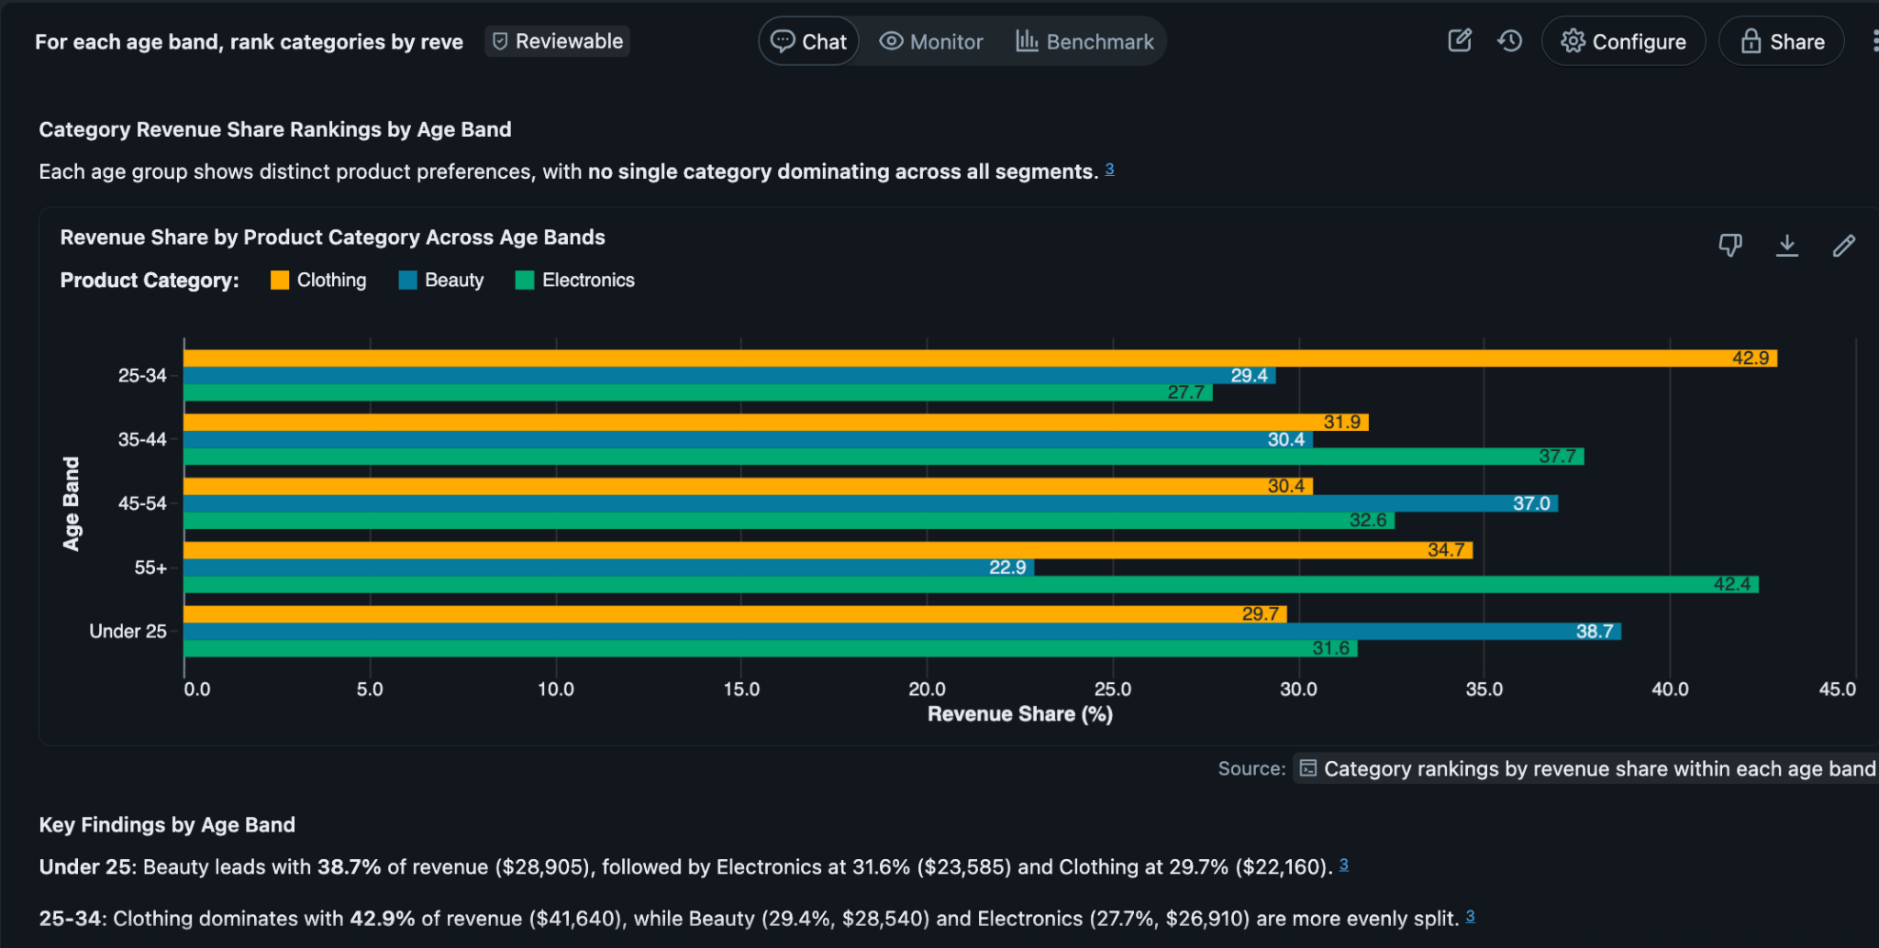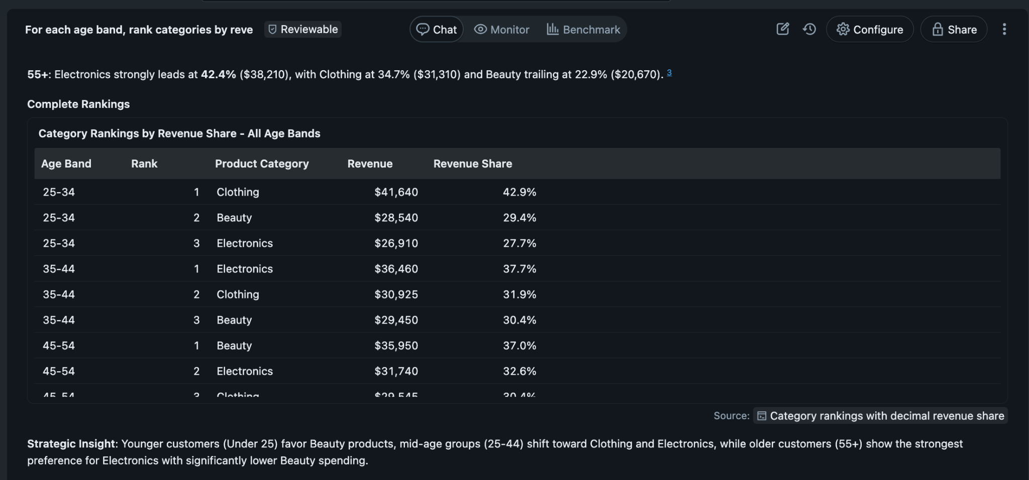
SQL Script
Question 1 :
SELECT SUM(Total Amount) AS revenue
FROM retail_sales_data;
Question 4:
SELECT Gender,
AVG(Total Amount) AS avg_basket,
COUNT(*) AS transactions
FROM retail_sales_data
GROUP BY Gender;
Question 5:
SELECT Product Category,
SUM(Total Amount) AS revenue,
SUM(Quantity) AS units
FROM retail_sales_data
GROUP BY Product Category
ORDER BY revenue DESC; -- change to units DESC for unit ranking
Key insights - what the agent revealed
Electronics brought in the most revenue at [X%], while Beauty sold the most units at [Y%]. That signals a classic mix: higher price and lower volume for Electronics, lower price and higher volume for Beauty.
Revenue hit its high in [Month YYYY] at ZAR [X] and dipped in [Month] at ZAR [Y]. Beauty showed a seasonal surge in [seasonal month], and Electronics peaked in [month], suggesting different demand curves by category.
The biggest average basket came from [segment, e.g., Females 45–54] at ZAR [X]. Shoppers under 30 over-indexed in Beauty and Clothing, while those 50+ leaned toward Electronics.
The top 10% of transactions drove [X%] of total revenue, indicating meaningful concentration among high-value baskets. Weekends delivered [X%] more revenue than weekdays, highlighting timing effects.
Data quality was generally solid: [N] minor total-amount mismatches were found, and the dataset spans [start] to [end].
Business recommendations - what to do next
Time promotions: in the Electronics peak, push bundle offers to the 50+ segment; in Beauty’s seasonal month, run volume-led promos targeting under‑30s.
Protect the baseline: keep steady Clothing offers, and add Beauty cross‑sell add‑ons from Clothing to lift basket size.
Test pricing: trial a 5 to 10% discount on Electronics in the softest month to trade margin for unit velocity; track revenue and basket size impact to decide whether to scale.
Operate to demand: increase staffing and stock 1 to 2 weeks before expected peaks; aim for >98% in‑stock on top SKUs to avoid walkaways.
Measure and iterate: track revenue, units, average basket, segment share, and promo ROI, with simple MoM targets (e.g., +3% revenue) to keep momentum visible.
Conclusion - what worked, what was hard, what to change
What worked: clear table/column descriptions, explicit assumptions (recent time window, age bands), and SQL validations, all of which improved accuracy and trust.
What was hard: ambiguous timeframes, mixing up units vs revenue in a few questions, and resolving a small number of total-amount mismatches.
What to change next time: add derived fields (month, weekday, age band), pre-define comparison windows, and include margin data. all surfaced in a small KPI dashboard to make trade-offs and timing clearer.

